Kubernetes Task-06
Task 1 — Config Map from a directory → Environment Variables
Objective
Create a directory containing multiple configuration files, create a ConfigMap from that directory, and inject the ConfigMap values into a Pod as environment variables.
Step 1 — Create a directory
On k8s-master: mkdir -p ~/configmap-dir
Step 2 — Create two configuration files
echo "Narayana" > ~/configmap-dir/username
echo "Hyderabad" > ~/configmap-dir/city
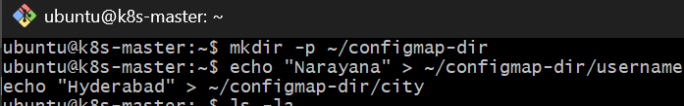
Verify: ls -l ~/configmap-dir
Then: cat ~/configmap-dir/username
cat ~/configmap-dir/city
You should see: Narayana
Hyderabad
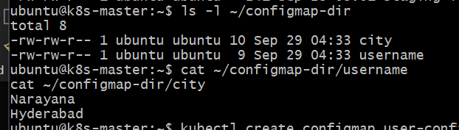
Step 3 — Create ConfigMap from the directory
kubectl create configmap user-config --from-file=/home/ubuntu/configmap-dir/
Verify: kubectl get configmap user-config
Then: kubectl describe configmap user-config
You should see both keys: username
City
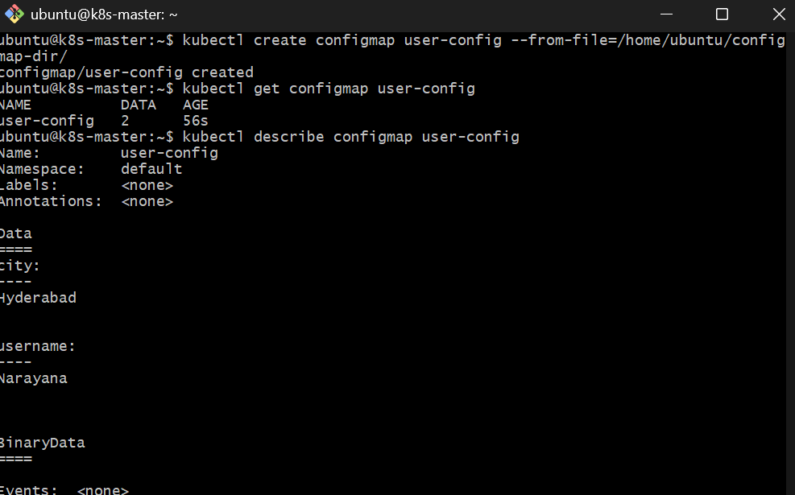
Step 4 — Create the Pod YAML
Create: vi configmap-env-pod.yml
Add:
apiVersion: v1
kind: Pod
metadata:
name: configmap-env-pod
spec:
containers:
- name: nginx
image: nginx:latest
envFrom:
- configMapRef:
name: user-config
Save and exit.
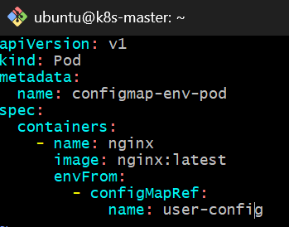
Step 5 — Create the Pod
kubectl apply -f configmap-env-pod.yml
Check: kubectl get pod configmap-env-pod
Expected:
NAME READY STATUS RESTARTS AGE
configmap-env-pod 1/1 Running 0 ...
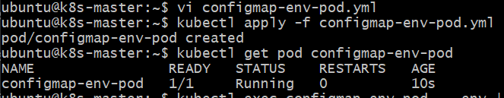
Step 6 — Verify the environment variables
Run: kubectl exec configmap-env-pod -- env | grep -E 'username|city'
Expected:
username=Narayana
city=Hyderabad
Important point
Because we used:
envFrom:
- configMapRef:
name: user-config
every key in the ConfigMap becomes an environment variable inside the container.
So:
ConfigMap
|
+-- username=Narayana
|
+-- city=Hyderabad
|
v
Pod
|
+-- $username
+-- $city
Task 2 — ConfigMap from a File → Mount as Volume
Objective
Create a ConfigMap from a single configuration file, mount that ConfigMap into a Pod as a volume, and verify that the configuration is available as a file inside the container.
Step 1 — Create the configuration file
Run: cat > app-config.conf <<'EOF'
APP_NAME=MyApplication
APP_ENV=development
APP_PORT=8080
EOF
Verify: cat app-config.conf
Expected:
APP_NAME=MyApplication
APP_ENV=development
APP_PORT=8080
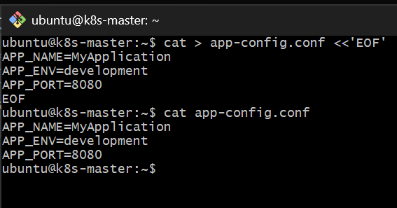Step 2 — Create ConfigMap from the file
Run: kubectl create configmap app-config --from-file=app-config.conf
Verify: kubectl get configmap app-config
Then: kubectl describe configmap app-config
You should see:
Data
====
app-config.conf
----
APP_NAME=MyApplication
APP_ENV=development
APP_PORT=8080
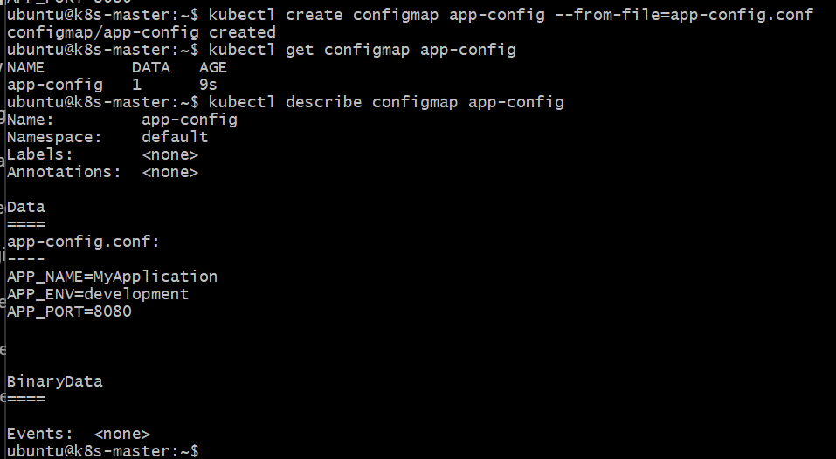
Step 3 — Create Pod YAML
Create: vi configmap-volume-pod.yml
Paste: apiVersion: v1
kind: Pod
metadata:
name: configmap-volume-pod
spec:
containers:
- name: nginx
image: nginx:latest
volumeMounts:
- name: config-volume
mountPath: /etc/app-config
volumes:
- name: config-volume
configMap:
name: app-config
Save and exit.
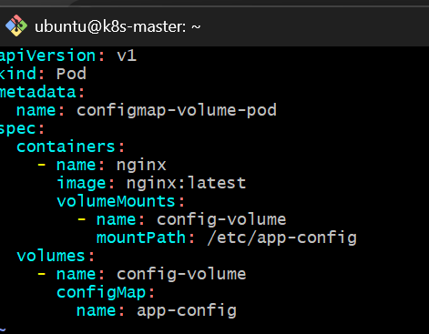
What this does
The ConfigMap:
app-config
|
| app-config.conf
v
Pod
|
v
/etc/app-config/app-config.conf
The important part is:
volumeMounts:
- name: config-volume
mountPath: /etc/app-config
and:
volumes:
- name: config-volume
configMap:
name: app-config

Step 4 — Create the Pod
kubectl apply -f configmap-volume-pod.yml
Check: kubectl get pod configmap-volume-pod
Expected:
NAME READY STATUS RESTARTS AGE
configmap-volume-pod 1/1 Running 0 ...
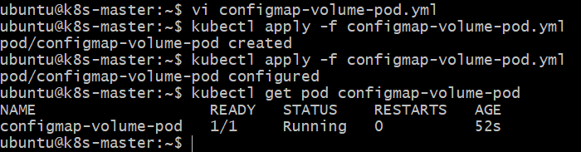
Step 5 — Verify the mounted file
First check the directory:
kubectl exec configmap-volume-pod -- ls -l /etc/app-config
You should see: app-config.conf
Now read the file:
kubectl exec configmap-volume-pod -- cat /etc/app-config/app-config.conf
Expected:
APP_NAME=MyApplication
APP_ENV=development
APP_PORT=8080
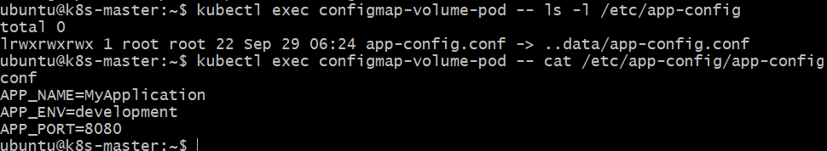
Task 3 — Create Secret and Inject into Pod as Environment Variables
Objective
Create a Kubernetes Secret containing:
- username
- password
Then inject both values into a Pod as environment variables.
Step 1 — Create the Secret
Run: kubectl create secret generic app-secret \
--from-literal=username=admin \
--from-literal=password='P@ssw0rd123'
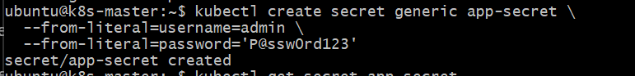
Step 2 — Verify the Secret
kubectl get secret app-secret
Expected:
NAME TYPE DATA AGE
app-secret Opaque 2 ...
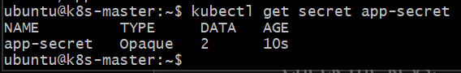
Check the keys: kubectl describe secret app-secret
You should see:
Data
====
password: 10 bytes
username: 5 bytes
Important: Kubernetes does not display the actual Secret values in describe.
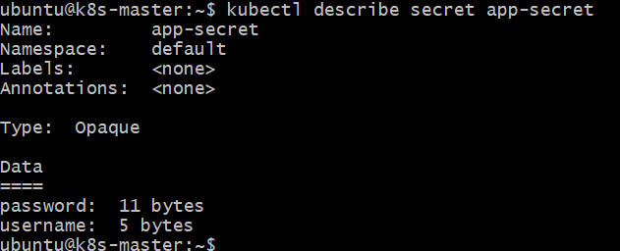
Step 3 — Create the Pod YAML
Create: vi secret-env-pod.yml
Paste: apiVersion: v1
kind: Pod
metadata:
name: secret-env-pod
spec:
containers:
- name: nginx
image: nginx:latest
envFrom:
- secretRef:
name: app-secret
Save and exit.
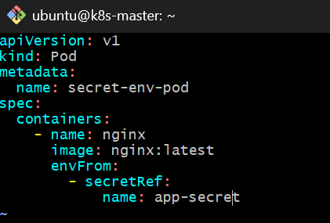
Step 4 — Create the Pod
kubectl apply -f secret-env-pod.yml
Check: kubectl get pod secret-env-pod
Expected:
NAME READY STATUS RESTARTS AGE
secret-env-pod 1/1 Running 0 ...
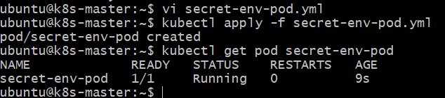
Step 5 — Verify the environment variables
Run: kubectl exec secret-env-pod -- env | grep -E 'username|password'
Expected:
username=admin
password=P@ssw0rd123
This demonstrates:
Secret
├── username=admin
└── password=P@ssw0rd123
|
v
secretRef
|
v
Pod
|
├── username
└── password
Task 4 — Secret YAML → Volume Mount
Step 1 — Create the Secret YAML
Run: vi secret-volume.yml
Paste:
apiVersion: v1
kind: Secret
metadata:
name: database-secret
type: Opaque
stringData:
username: dbadmin
password: DBpass123
Save and exit.
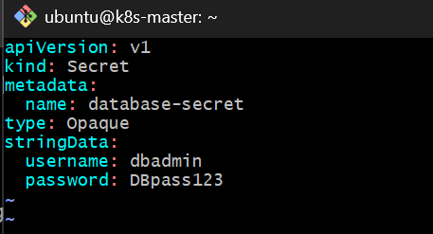
Why stringData?
We are using:
stringData:
so Kubernetes accepts the values as normal text and automatically stores them encoded in the Secret.
You don't need to manually calculate Base64 values.

Step 2 — Create the Secret
Run: kubectl apply -f secret-volume.yml
Verify: kubectl get secret database-secret
Expected:
NAME TYPE DATA AGE
database-secret Opaque 2 ...
Check the Secret keys: kubectl describe secret database-secret
You should see:
Data
====
password: 10 bytes
username: 7 bytes
Again, the actual values won't be displayed by describe.
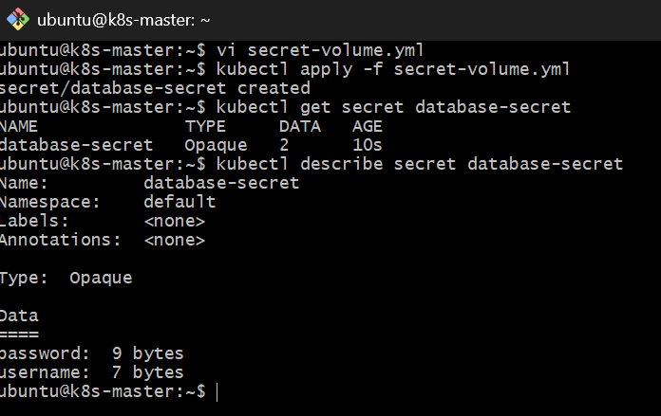
Step 3 — Create the Pod YAML
Run: vi secret-volume-pod.yml
Paste: apiVersion: v1
kind: Pod
metadata:
name: secret-volume-pod
spec:
containers:
- name: nginx
image: nginx:latest
volumeMounts:
- name: secret-volume
mountPath: /etc/database-secret
readOnly: true
volumes:
- name: secret-volume
secret:
secretName: database-secret
Save and exit.
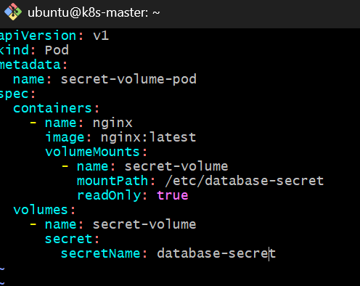
What happens here?
Kubernetes will create files automatically:
/etc/database-secret/
├── username
└── password
The contents will be:
username → dbadmin
password → DBpass123
Notice that we're not using environment variables in this task.
The Secret is being exposed as files.
Step 4 — Create the Pod
Run: kubectl apply -f secret-volume-pod.yml
Check: kubectl get pod secret-volume-pod
Expected:
NAME READY STATUS RESTARTS AGE
secret-volume-pod 1/1 Running 0 ... 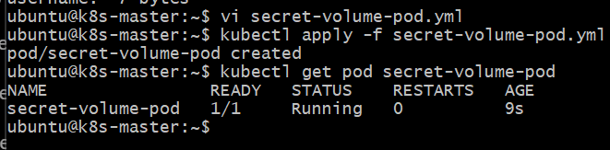
Step 5 — Verify the Secret files
First list the directory: kubectl exec secret-volume-pod -- ls -l /etc/database-secret
Expected:
password
username
Now verify username: kubectl exec secret-volume-pod -- cat /etc/database-secret/username
Expected: dbadmin
Verify password: kubectl exec secret-volume-pod -- cat /etc/database-secret/password
Expected: DBpass123
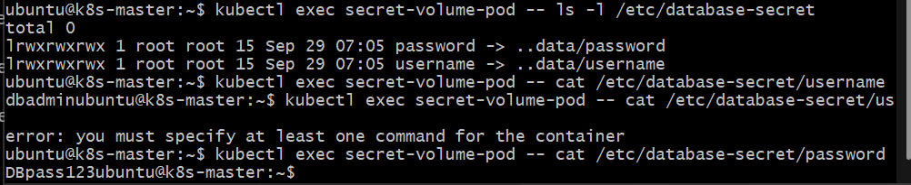
Task 5 — ConfigMap as Environment Variables + Secret as Files
Objective
Use both configuration mechanisms in the same Pod:
- ConfigMap → environment variables
- Secret → files through a volume mount
We'll reuse the existing user-config ConfigMap and database-secret Secret created in Tasks 1 and 4.Step 1 — Verify the existing ConfigMap and Secret
Run: kubectl get configmap user-config
kubectl get secret database-secret
Expected:
user-config
database-secret
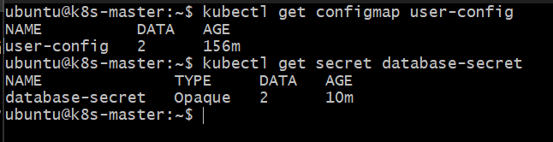Step 2 — Create the Pod YAML
Run: vi configmap-secret-pod.yml
Paste: apiVersion: v1
kind: Pod
metadata:
name: configmap-secret-pod
spec: containers:
- name: nginx
image: nginx:latest
envFrom:
- configMapRef:
name: user-config
volumeMounts:
- name: secret-volume
mountPath: /etc/database-secret
readOnly: true
volumes:
- name: secret-volume
secret:
secretName: database-secret
Save and exit.
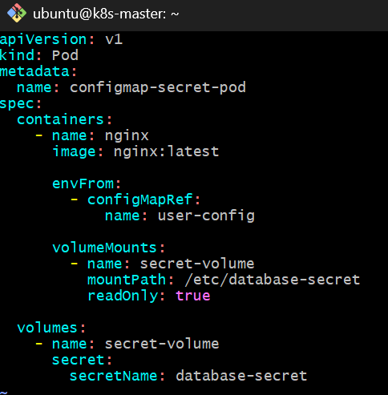
Step 3 — Create the Pod
kubectl apply -f configmap-secret-pod.yml
Check: kubectl get pod configmap-secret-pod
Expected:
NAME READY STATUS RESTARTS AGE
configmap-secret-pod 1/1 Running 0 ... 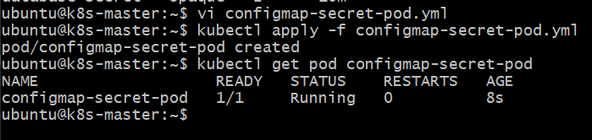Step 4 — Verify ConfigMap environment variables
Run: kubectl exec configmap-secret-pod -- env | grep -E 'username|city'
Expected: username=Narayana
city=Hyderabad
So the Pod is receiving the ConfigMap as environment variables. 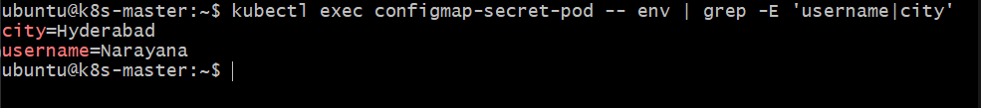Step 5 — Verify Secret files
List the mounted directory: kubectl exec configmap-secret-pod -- ls -l /etc/database-secret
Expected: password
username
Verify username: kubectl exec configmap-secret-pod -- cat /etc/database-secret/username
Expected: dbadmin
Verify password: kubectl exec configmap-secret-pod -- cat /etc/database-secret/password
Expected: DBpass123
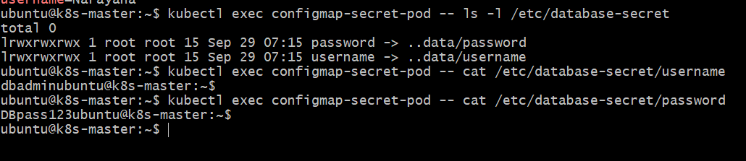Final Architecture
Your Pod now has two different configuration sources:
Kubernetes
|
+----------+----------+
| |
ConfigMap Secret
user-config database-secret
| |
| |
v v
Environment Variables Volume Mount
| |
v v
Pod container /etc/database-secret/
| |
| +-- username
| +-- password
|
+-- username=Narayana
+-- city=Hyderabad

